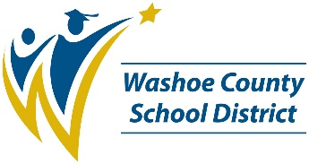**ALLEN ELEMETARY SCHOOL**

*2023-2024 SCHOOL PERFORMANCE PLAN*

**Student Success Goal**

By the end of the 2023-24 school year, 50% of students will score at grade level or above on iReady Diagnostics in both ELA and Math.

To support students to achieve this goal, we will:

1. ELD facilitator and Learning Facilitator (BLF) continue to attend professional learning around coaching and professional development.
2. ELD and BLF to attend PLCs and grade level meetings to support planning, data analysis, intervention, and enrichment planning.
3. Teachers use Leveled Literacy program for ELA intervention groups ESSA.
4. Teacher use Envision/Bridges intervention programs for intervention groups in Math.
5. All students included in Tier I ELA and Math instruction using language acquisition strategies (GLAD, Ellevation).
6. Teachers use iReady, MAP, and common formative assessments to review student learning and plan next steps in PLCS.

**Student, Staff, and Family Partnerships Goal**

By the end of the 2023-24 school year, 85% of all students will attend school more than 90% of the time.

To support students and families to achieve this goal, we will:

1. Combine attendance with PBIS committee.
2. Fund student prizes for quarterly drawings
3. Students receive monthly attendance certificates/pencils for perfect attendance.
4. Messaging to families regarding importance of attendance

**Resources for Parents and Families**

| **Quick Tips for Parents and Families** |  | **Resource Links** |
| --- | --- | --- |
| **Get involved!** Contact Allison Bartolo for information about volunteering with our school. |  | **Infinite Campus Parent Portal**  *See your child’s grades, assignments, attendance information and important updates.*  **www.washoeschools.net/ICparent** |
| **Stay connected!** Let the front office know if your phone number, email, or home address has changed. |  | **Family Resource Centers**  *Basic needs assistance, resource referrals, and help with accessing services like SNAP.*  **www.washoeschools.net/FRC** |
| **Know your child’s teachers!** We are here to support your child’s learning journey. |  | **Care Solace**  *Free and confidential help to access mental health care providers in your community.*  **www.washoeschools.net/Care** |